November 15, 2011
Dear John,
Thank you for your email of Nov. 3, asking our opinion on SB 2053, “An Act relative to certain projects referred to the Massachusetts historical commission for consultation.” Our delayed response in no way reflects upon the importance and urgency of this matter: Our AIA chapter that includes Massachusetts should oppose this bill in the strongest possible terms, and as soon as possible. We understand the bill is indeed alive and in committee, although it appears to have moved back and forth among several committees it is now seen as related to regulatory statutes rather than tourism.
The bill would terminate Massachusetts Historical Commission’s current responsibility (and opportunity) to review state or private actions that would have adverse effects on properties that are eligible for listing in the State Register of Historic Places, but have not yet been listed. Communities in the state have inventories of historic resources, and only a fraction of these have been listed in the state register. It is time consuming and expensive to get properties listed. Moreover, MHC has only a limited number of staff to handle nominations. Overall, there are thousands of properties that could be listed. Thus, by removing these from MHC’s oversight, the bill’s sponsors will eviscerate protections for the state’s historic legacy.
This bill is not designed to be good policy. It is explicitly intended to punish the Massachusetts Historical Commission and to soothe the feelings of a well-connected developer. We of course do not know exactly what happened between the developer and MHC, but the developer claims MHC made unreasonable demands, in connection with mitigating adverse effects, and Secretary Galvin says he didn’t, and moreover, does not demand what the developer says that the MHC required. If the developer really wanted to go forward with the project, he would work this out. It may be he does not want to proceed with the project and used this issue to cover his exit.
In any event on the basis of this single developer’s ire, state and local officials from the area would wreck the review process that is absolutely vital to protect historic resources in this state. The Meditech project may proceed or not; meanwhile, these officials will have exposed a huge number of the state’s historic properties, located far from Fall River and in no way connected to that dispute, to any public or private action the proponent desires, without any review or opportunity to find ways to reduce damage to the resources. This is irresponsible, and it’s unconscionable that the myopic Fall River officials would go to such lengths. The bill must be opposed.
We urge you to write as soon as possible to oppose this bill. You have as much of the information we have. We attach a letter that Boston Preservation Alliance sent, in case you haven’t seen it.
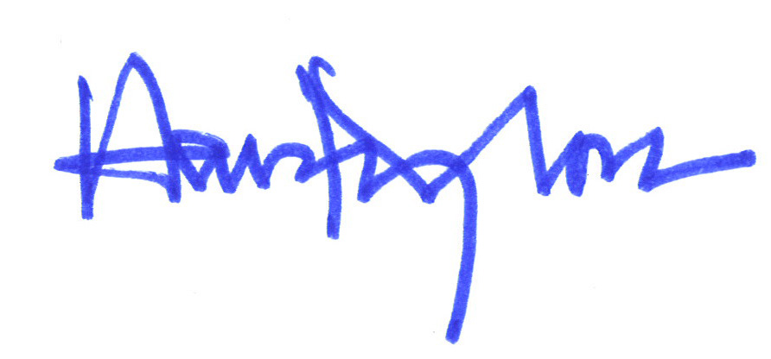
Sincerely,

BSA Historic Resources Committee

